**Holmer C E Academy School Uniform**

School Uniform is available to order from the School Trends Website.

Please log on to [www.schooltrends.co.uk](http://www.schooltrends.co.uk)

Select the Parent or Student box 

Type the School Postcode in the box – HR4 9RX

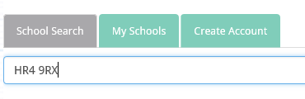

Click on the school name that appears below

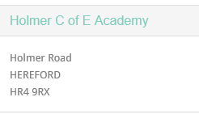

Select the Uniform you wish to buy and proceed as you do for any online shopping

