 |  |  | Holmer C of E Academy
 | Topic: Technology around us |  | Year: 2 | Strand: Pictograms
What should I already know?  - To have experience of grouping data.  - To label objects and group them based on different properties. |  | What will I find out by the end of the unit? Vocabulary  To recognise that we can count and compare objects using tally charts To enter data onto a computer To use a computer to view data in a different format To use pictograms to answer simple questions about objects To recognise that people can be described by attributes To create a pictogram to arrange objects by an attribute To explain that we can present information using a computer To give simple examples of why information should not be shared Data Facts and statistics collected together to analysis  Tally chart A method of collecting data. For example, 1111 = 4  Pictogram A chart that uses pictures to represent data  Format The way in which something is arranged  Attribute A quality or characteristic of someone, e.g. funny  Conclusions Gathering information together to come up with an outcome.
Computing Skills and Enquiry
- Use technology purposefully to create, organise, store, manipulate, and retrieve digital content
- Use technology safely and respectfully, keeping personal information private; identify where to go for help and support when they have concerns about content or contact on the internet or other online technologies

 | Holmer C of E Academy - Computing
Topic: Technology around us | Year: 2 | Strand: Pictograms
- Use this tally chart to help you answer the questions. |  | 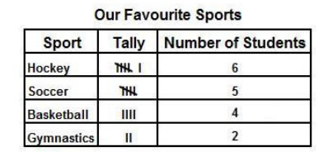  1. What is the least favourite sport? ______________________  2. How many children prefer hockey?  3. How many children are there altogether? _________________
- Use this pictogram to help you answer the questions. |  | 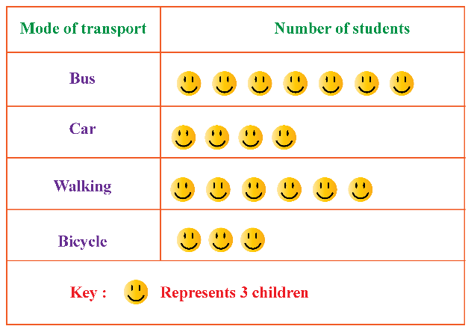  1. How many children go to school by car? ______  2. How many children walk to school? _______  3. What is the least popular way to travel to school? ________
- List 6 different attributes.
- “A stranger has asked me to share information about where I live. I should give this information.” True or false?

