SEND: Speech, Language and Communication
 | Tips/ Advice/ Strategies | Resources- www’s / docs
Articulation (Pronunciation and talking) | What are the building blocks necessary to develop articulation (pronunciation and talking)?  - Attention and concentration: Sustained effort, listening and doing activities without distraction and being able to hold that effort long enough to get the task done (e.g. being able to attend to speech and sounds long enough to be able to process the information).  - Hearing: For detection of speech sounds.  - Good middle ear functioning most of the time (e.g. a child with on-going ear infections, ‘glue ear’ or colds which block the ears may have fluctuating hearing levels which can affect speech).  - Process speech sounds, identify and hear differences between sounds.  - Muscle coordination: The ability to move and coordinate the muscles involved in producing sounds (e.g. diaphragm, lips, tongue, vocal cords, jaw and palate).  - Understanding that sounds convey meaning  What activities can help improve articulation (pronunciation and talking)?  - Naming items together when completing tasks such as looking at a book, in the car, looking outside, while playing and during shopping.  - Copying facial expressions in the mirror (e.g. smiling, kissing, licking lips).  - Playing something together that the child really enjoys and throughout the game model words with which they are having difficulty.  - Modeling and using different sounds during interactions and in play (e.g. “s” is the snake sound, “sh” the baby is sleeping).  - Listening to and identifying sounds in words (e.g. “shoe” starts with the “sh” sound).  - Correcting: If a child says a word incorrectly, model the correct production back to them but there is no need to make them say it again (e.g. child: “Look at the tat”. adult: “Yes, it’s a cat” and then continue with the conversation). This helps to provide a subtle, positive correction by modelling the correct response rather than highlighting that the child has said it incorrectly. | https://mommyspeechtherapy.com/?page_id=55  Printable resources for individual speech sounds, articulation app practice, speech sound development  https://apps.apple.com/us/app/little-stories-lite/id1327557030 Little Stories Lite app  Articulation database:-  https://www.quia.com/pages/havemorefun.html  Handout: Unclear speech.pdf  https://chatterpack.net/blogs/blog/list-of-free-speech-language-communication-and-send-resources-for-schools-and-parent-carers  Lots of resources and links
Expressive Language  means being able to put thoughts into words and sentences, in a way that makes sense and is grammatically accurate | How you can help  There are lots of strategies you can use.  Some of our top tips are:  - Set a good example: children learn to talk by watching, listening and copying. Set a good example by using clear and simple language; add gestures or signs to communicate more information  - Add a little more: show children how they can extend their language by using phrases one or two words longer than they use themselves. If the child says “bucket”, you could say “fill the bucket”, if they say “mummy gone”, you could say “mummy’s gone to work”  - Follow their lead: be responsive to children’s interests and join in with their play – this can help them take part in extended conversations which are great for learning more about talking  - Repetition: children learn new words by hearing them repeated in different places and at different times. For example, as they are learning the word ‘bucket’, they will need to see and experience a real bucket, a toy and a picture in a book as you say its name each time. You can go on to talk about what it is made of and used for when the child is ready to learn more  - Commenting: to help children join in with the conversation, try to comment on what is happening rather than ask them questions – a useful rule is to aim to make four comments for every question you ask. If you are playing in the sand you could say “you’re digging… fill it up… pour it out… you’re making a castle… I wonder who lives in the castle?”  - Practice makes perfect: talking, like any other skill, takes practice. Create as many opportunities as you can for conversations between children and with other adults | 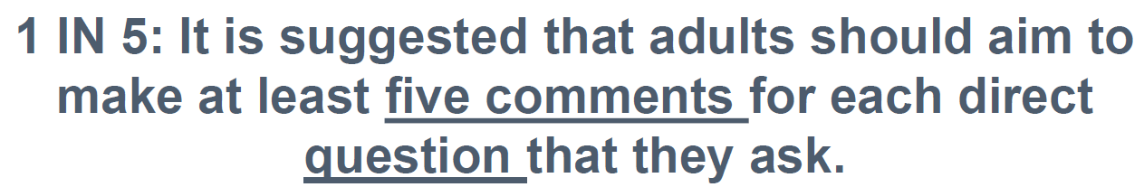  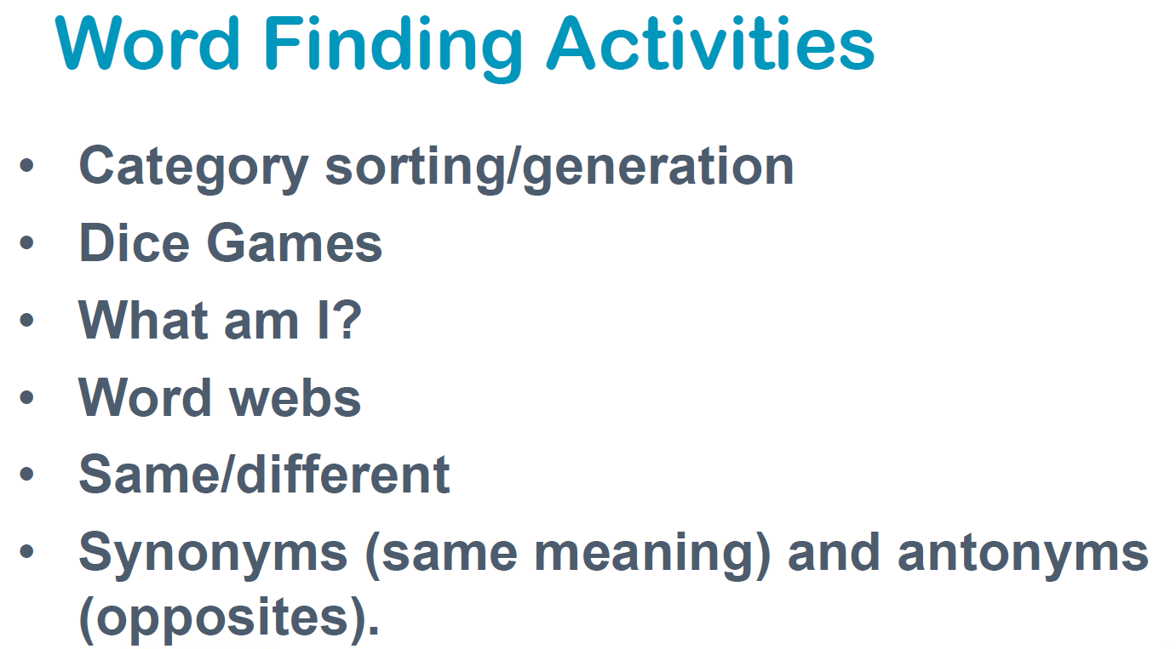  Vocabulary building games:  guess the category.doc  Which one doesn’t belong?.doc  Name the category cards.doc  What am I?.doc (animals)  What am I food themed.doc  What am I? Household items guessing games  Wordless books- you can ask them direct questions like, “What is this?” or “What color is this?”. You can expand upon your child’s answers by saying things like, “You’re right; that’s a cat. He’s a black cat”. This will help model language and provide good input as well as working on output.  Conversation cards.doc  Activities to develop expressive language skills primary.doc  Spot the dog games:  https://www.funwithspot.com/make-a-spot-story/  https://www.funwithspot.com/fun-and-games/find-and-cook#  Vocabulary games: https://www.funbrain.com/  https://www.quia.com/pages/havemorefun.html (database)  Sequencing: https://www.quia.com/pages/sequencingfun.html  Picture sequencing: https://www.turtlediary.com/game/picture-sequencing-kindergarten.html  Sequencing 3 little pigs: https://www.education.com/game/sequencing-three-little-pigs/  Sequencing app: https://apps.apple.com/us/app/gosequencing/id1000754477  Grammar games: https://www.quia.com/pages/grammarcrackers.html

Receptive Language-  means the ability to understand information. It involves understanding the words, sentences and meaning of what others say or what is read. | 1)Wh questions  answering WH questions takes a lot of different language skills.  A child must:  - Understand the question word  - Understand the grammar of the question  - Understand each vocabulary word (not just the question word)  - Makes sense of the information and the social context  - Formulate a response  - Put the words together (syntax & semantics)  - Give a response  Expectations  1–2 years  - Answers “where” questions by looking/pointing at the correct place and/or using words  - Answers “what” questions by choosing an object or responding verbally  - Answers age-appropriate yes/no questions with words or gestures  - Asks “what’s that” questions?  2–3 years  - Answers “where,” “what,” “what-doing,” and “who” questions.  - Answers age-appropriate critical thinking questions (i.e., what do you wear when it is cold?)  Age 3  - Answers “who,” “why,” “where,” and “how” questions  - Answers “if-what” questions (i.e., “If you are hungry, what do you do?)  Age 4  - Answers “when” and “how many” questions (new)  - Answers “who,” “why,” “where,” “how,” and “if-what” questions  - Asks “why,” “what,” “where,” “when,” and “how” questions  2) Following directions (see below)  - Foster listening skills through play  3) Working Memory- see working memory.pdf  4) Games with household objects – Guess Who board game  5) Barrier Games- see barrier games.pdf | Opposites game.doc  1. Simon Says  How To Play: The leader says “Simon says.....and then a direction.” For example, the leader says “Simon says turn around.” Everyone playing has to turn around. If the leader does not say “Simon says” before giving a direction, then the direction is not to be followed. If a person follows a direction without hearing “Simon says” first, he or she loses.  Why Play? This works on following directions and attention.  2. Treasure Hunt  How To Play: Hide a “prize” somewhere in the house. Give your child directions to follow to find the treasure. Be silly. For example, if you hide a toy under the bed. First say, jump 3 times. Touch your toes. Walk through the door. Pick up the bear and put it down. Look under the bed. Children will find it funny.  Why Play? This game will work on following directions and listening. You can make it as easy or hard as you want to!  3. Clean Up Game  How To Play: Take turns giving directions for what to clean up. Have your child give you directions and you give your child directions. Your child will have fun telling mommy and daddy what to do!  Why Play?: The house will get cleaned AND your child will work on listening. Multi-tasking at its best!  4. Sticker Game  This may be the easiest to do as we need or should clean up every day!  How To Play: Take turns giving directions for what to clean up. Have your child give you directions and you give your child directions. Your child will have fun telling mommy and daddy what to do!  Why Play?: The house will get cleaned AND your child will work on listening. Multi-tasking at its best!  5. Reading  If you only have time to try one game today, try reading! It really is the best way to build vocabulary skills.  How To Play: When reading with your child, don’t just rush through and just read the words. Instead, point to pictures while you read. Talk about the illustrations. Ask feeling questions such as "how does the character feel?” Ask other WH questions like when, where, who? You can even ask prediction questions such as "what do you think will happen next?” Your child may not be able to answer these questions; however, you can answer the questions! Talk about your thinking process. Your child will learn how to answer questions and how to think about stories by listening to you!  Why Play?: Instilling a love for reading at a young age will only benefit your child!  Basic concepts.pdf  Teaching 52 basic concepts.pdf  Prepositions.pdf  Guess my snowman.pdf game  Guess my monster.pdf game  Barrier games- 40 barrier games.doc  Barrier game: Build a cupcake.pdf
Following Instructions | 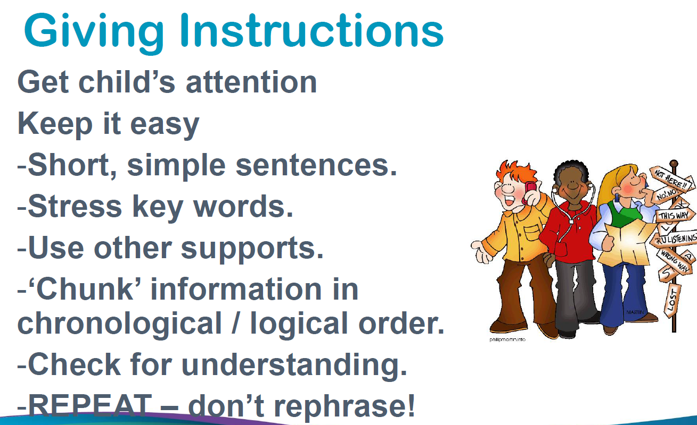 | Following 2 step instructions.doc  Listen and Do activity pack.doc  Listen and colour 3 key words.doc  Different ways of following directions.pdf  Mystery Picture Hunt.doc

