SEND: Sensory and physical

 | Tips/ Advice/ Strategies | Resources- www’s / docs
Fine Motor  Letter formation  Gross Motor/ hand/ body tension  Spatial awareness  HI- Hearing Impairment  VI- visual Impairment | What are Fine Motor skills?  Fine motor skills involve the use of the smaller muscle of the hands, commonly in activities like using pencils, scissors, construction with lego or duplo, doing up buttons and opening lunch boxes.  Fine motor skill efficiency significantly influences the quality of the task outcome as well as the speed of task performance.  Efficient fine motor skills require a number of independent skills to work together to appropriately manipulate the object or perform the task.  What skills do ‘fine motor skills’ include?  - Academics skills including  - Pencil skills (scribbling, colouring, drawing, writing)  - Scissors skills (cutting)  - Play  - Construction skills using lego, duplo, puzzles, train tracks  - Doll dressing and manipulation  - IT use (e.g. mouse and stylus manipulation)  - Self-care including  - dressing – tying shoelaces, doling up sandals, zips, buttons, belts  - eating – using cutlery, opening lunch boxes and food bags  - hygiene – cleaning teeth, brushing hair, toileting  Note: Visual perception (accurately using vision, ‘seeing’ and interpreting) is not strictly a fine motor skill but directly supports fine motor skill performance  Match the characteristics of two pictures amongst other similar pictures.doc  Herdolt Visual perception worksheets.pdf  - paste things onto paper  - clap hands  - touch fingers  - button and unbutton  - work a zipper  - build a tower of 10 blocks  - complete puzzles with five or more pieces  - manipulate pencils and crayons well enough to color and draw  - copy a circle or cross onto a piece of paper  - cut out simple shapes with safety scissors  Letter formation is the ability to write and form the letters of the alphabet in a legible way  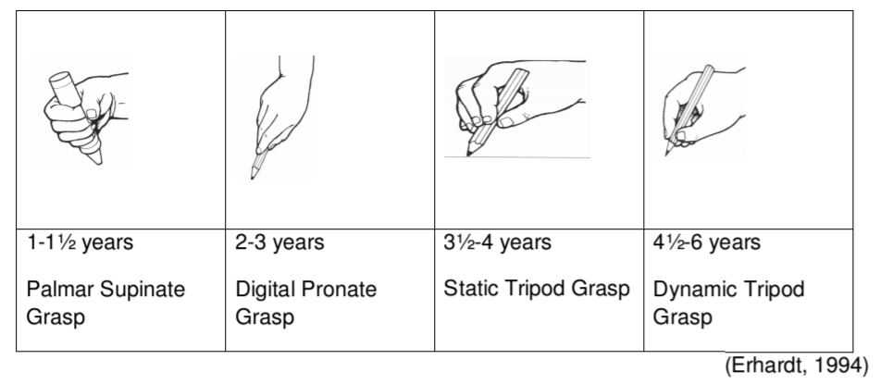  Letter formation is part of the development of fluent handwriting and forms the foundation for joining letters in the later school years.  It needs to become automatic so the child can concentrate on the content of their writing rather than having to use a lot of energy on how to write the letters.  Lots of practice is the best way to help letter formation become automatic.  A child should learn to copy basic pre-writing patterns and shapes. Beery (1997) proposed that a child will be ready for formal instruction in handwriting if they manage to master the first 8 figures of the Developmental Test of Visual-Motor Integration (VMI). Focus on precision of the following shapes:  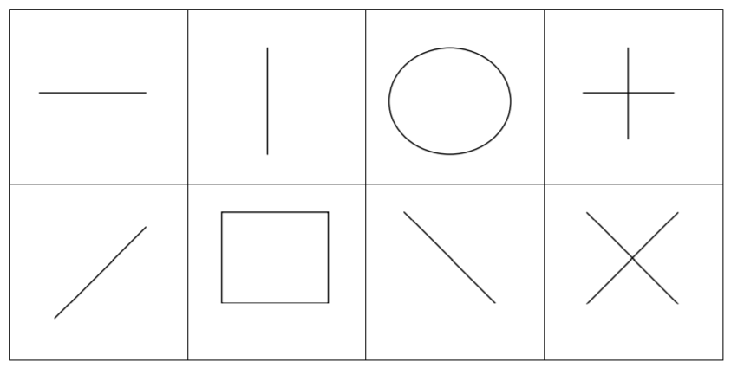  Developing Copying Skills –  Copy patterns using building blocks, matchsticks, coins, buttons, pegboards. Make it harder by taking away the original and asking the child to copy it from memory  Copy basic shapes and patterns using playdough, drawing in sand, using pipe cleaners  Mazes  Tracing activities. Developing Copying of Pre-Writing Shapes Use the pre-writing shapes (above) for the following activities:  Walk along a rope, string, or taped line  Follow-the-leader in different shapes  Making your own body look like the different shapes  Finger painting with shaving cream, paint, cornflour and water  Sand drawing with sticks, fingers, rakes, spades or even feet  Make the shapes out of pipe cleaners, Wikkistiks or string  Water painting on a brick wall using a paintbrush or a squirter bottle  Tracing with stencils using finger paints, marker pens or crayons  Join the stars/stickers to make the shapes  Drawing in the air with a ribbon stick or wand  Games with matching the different shapes  Use an upright chalkboard or paper pinned to a wall.  Gross motor (physical) skills are those which require whole body movement and which involve the large (core stabilising) muscles of the body to perform everyday functions, such as standing and walking, running and jumping, and sitting upright at the table.  Spatial awareness is knowing where your body is in space in relation to objects or other people. To have good spatial awareness you also need to understand and respond to a change in position from these objects. This is a complex skill that children develop from an early age.  Spatial awareness primary age children.pdf  Spatial Awareness Games.pdf  Sensory Circuits- Children, in particular, those with special educational needs, often need many breaks throughout their day to help them focus, stay on track, or calm in order to self-regulate. Even with home learning sitting at a desk all day/ for a long period can be a challenge. Sensory circuits offer calming, organising, and alerting activities for children.  Organising Activities:  - Heavy work (gives input to muscles and joints and causes fatigue)  - Wall pushes with hands and feet.  - Jumping on trampoline  - Popcorn jumps (jumping from a squat position and then landing back in a squat position)  - Wheelbarrow walking  - Crawling through tunnels  - Obstacle course  - Putting up/down chairs  - Sitting on “move and sit” therapy ball during classroom activities  - Passing the weighted balls  - Scooter board on belly and bottom (wall push-offs) 10+ reps  - Resistance Bands  Alerting Activities:  These are great to use with children who are quieter and tend to be lethargic. Also great to use after sitting activities to get the juices flowing again. Just make sure you do some type of calming activity after an Alerting activity before asking your child to sit back down to learn and work again.  - Bouncing on a therapy ball  - Upbeat music with a strong beat  - Vibrations on the arms, hand or back  - Swinging  - Jumping on a mini-trampoline  - Going outside  - Heavy work activities (moving a stack of books, re-arranging chairs, etc)  - Use two fingers on both sides of the spine, give a light upward stroke 3-5 times.  - Controlled spinning (no more than 10 repetitions at a time – do not do this if there is any known heart or seizure history)  - Jumping Jacks  - Push-Ups or Wall Push-Ups  - Skipping  - Running (Relay races, obstacle courses, etc)  Calming Activities:  - Rocking slowly over a ball on the belly  - Turning off the lights  - Swinging in a large circle with the child facing an adult (no spinning)  - Laying under a heavy blanket  - Soft music (spa music on Spotify)  - Beanbag squeezes  - Laying on the floor while an adult rolls a ball over top giving some deep pressure.  - Use of body sock/lycra material to wrap in  - Light touch/hard touch (depending on the child) – have the student brush a feather over their arms, or squeeze their arms with their hands for deep pressure.  - Using two fingers on both sides of the spine to give form downward strokes 3-5 times.  - Hand fidgets (such a play dough, Wikki Stix®, Thera-putty, etc.)  - Heavy work (moving furniture, a stack of heavy books, pulling a weighted backpack/rolling cart)  Coronavirus and support for deaf children – information for families (blog)  https://www.ndcs.org.uk/blog/coronavirus-and-support-for-deaf-children-information-for-families/?utm_campaign=2020%2003%20Professionals%27%20Update%20UK&utm_source=emailCampaign&utm_content=&utm_medium=email  Information and support (childhood deafness, language and communication, education and learning, products and technology, parenting and family life, being deaf friendly), free magazine: https://www.ndcs.org.uk/information-and-support/  Playtime tips and ideas: https://www.ndcs.org.uk/information-and-support/parenting-and-family-life/parenting-a-deaf-child/playtime-tips-and-ideas/?gclid=EAIaIQobChMI6a767u_J6AIVh8VkCh0Kzw2GEAAYASAAEgJSyvD_BwE  Resources for parents of blind or partially sighted children-  https://www.rnib.org.uk/children-young-people-and-families/resources-parents-blind-or-partially-sighted  Books, products and accessible learning: https://www.rnib.org.uk/practical-help/children-young-people-and-families/resources-parents-blind-or-partially-sighted/books-and-reading/books-products-and-accessible-learning | Fine motor development chart: https://childdevelopment.com.au/resources/child-development-charts/fine-motor-developmental-chart/  FineMotorActivitiesForHome.pdf  Fine motor skills nhs.pdf  Developing fine motorskills.pdf  https://theimaginationtree.com/40-fine-motor-skills-activities-for-kids/  Writing readiness (pre-writing skills)  https://childdevelopment.com.au/areas-of-concern/writing/writing-readiness-pre-writing-skills/  Low muscle tone: https://childdevelopment.com.au/areas-of-concern/diagnoses/low-muscle-tone/  Crossing the midline: https://childdevelopment.com.au/areas-of-concern/fine-motor-skills/crossing-the-bodys-midline/  Hand control: https://childdevelopment.com.au/areas-of-concern/fine-motor-skills/hand-control/  Visual perception: https://childdevelopment.com.au/areas-of-concern/visual-perception/  Self care:  https://childdevelopment.com.au/areas-of-concern/self-care/self-care-skills/  Motor activities to improve handwriting skills.pdf  non-pencil handwriting activities to work on the skills needed for handwriting:  Tweezer activities  Eye-dropper play  Using playdough to address Pencil Grasp  Sorting beads by color  Dropping coins into a piggy bank  Hand and finger aerobics  OT mum letter formation tips and strategies.pdf  Shape copying early handwriting.doc  Letter formation apps:  https://www.yellow-door.net/products/letter-formation-app/  An interactive model for tracing characters: https://www.doorwayonline.org.uk/activities/letterformation/  Animations and worksheets- https://www.teachhandwriting.co.uk/continuous-cursive-beginners-choice-3.html  Editable cursive writing boards dotted.doc  Editable cursive writing boards.doc  www.letterjoin.co.uk  (interactive, print outs, videos)  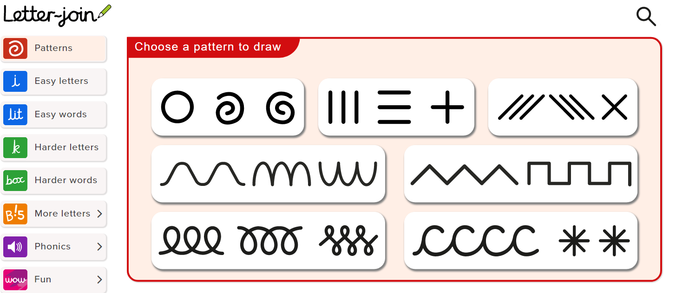  Interactive patterns  Easy letters:  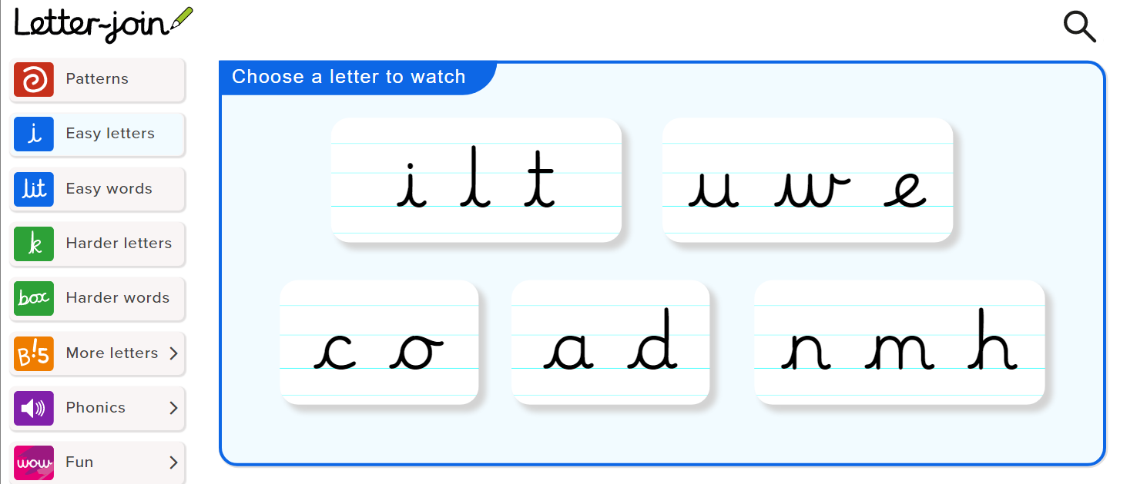  Easy words:  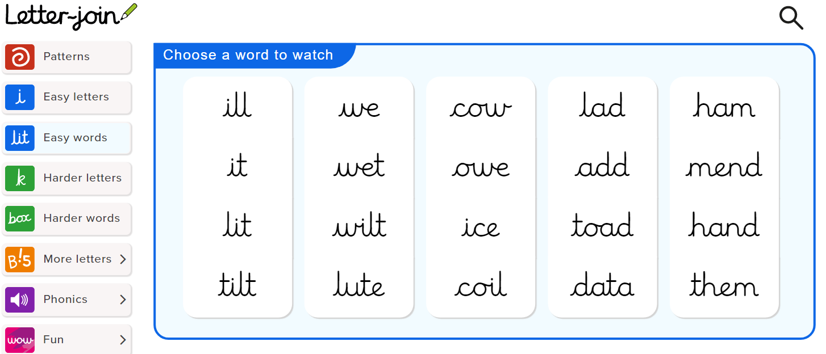  Hard letters:  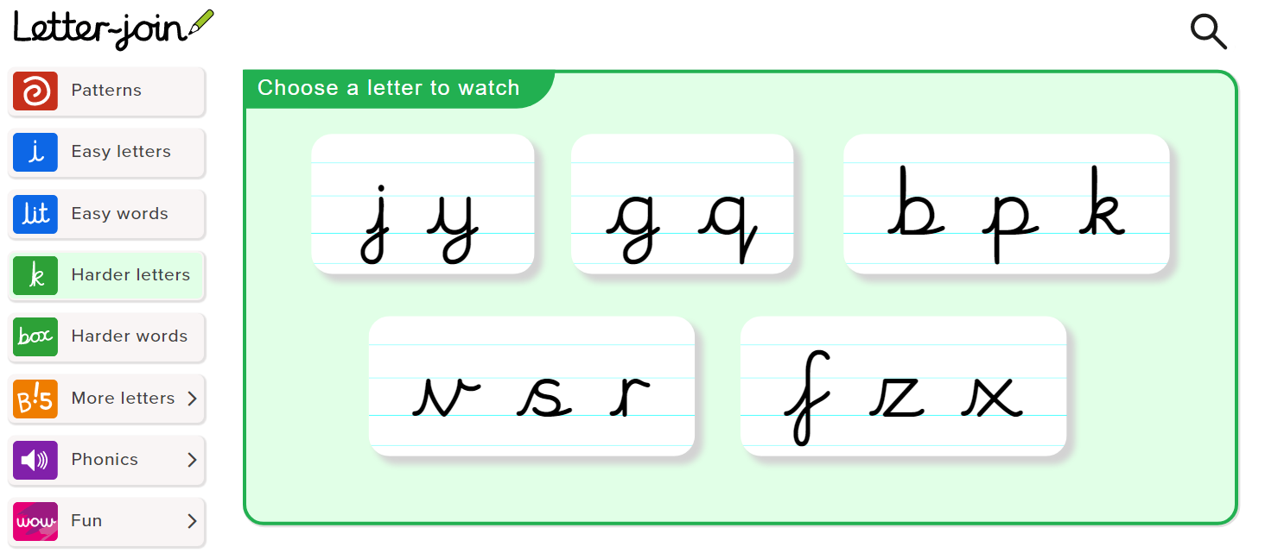  Harder words: 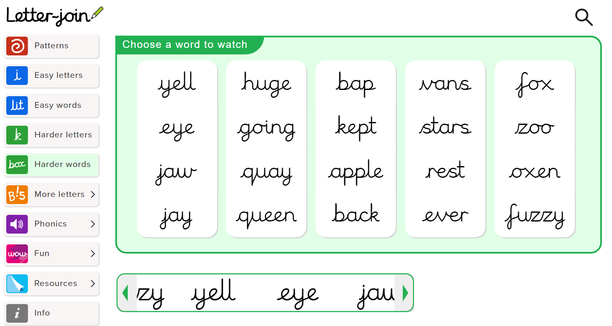  At home core strength ideas.JPG  1st move a gross and fine motor skills resource.pdf  Active classrooms movement breaks.pdf  Hopscotch, keep yuppy with a balloon (don’t let the balloon touch the ground!), trampoline, build your own assault course, move like an animal, tape balance beam, skipping, knock down (stack plastic cups and knock them down with a soft ball),  Assert Yourself - 05 - Reducing Physical Tension relaxation.pdf  the-wiggle-jar move like an animal movement break cards.pdf  https://www.gonoodle.com/good-energy-at-home-kids-games-and-videos/good-energy-at-home-more-2/  interactive games and activities for movement breaks  32 Free brain break video clips for kids  https://www.learningstationmusic.com/blog/2014/07/23/32-free-energizing-brain-breaks-vids-kids/  Suggested Apps: There are many apps available which could help you or your deaf child in many aspects of everyday life. Some apps are developed especially for deaf people, others are mainstream apps with a deaf angle  https://www.ndcs.org.uk/information-and-support/products-and-technology/apps-with-a-deaf-angle/  Websites: https://braillebug.org/ (write name in braille, secret codes, jumble puzzles)  https://www.cricksoft.com/uk/clicker/clicker-at-home reading and writing software (read aloud)  Audible Talking Books:  https://www.audible.co.uk/?source_code=M2M30DFT1BkSH1015140052&&ipRedirectOverride=true

