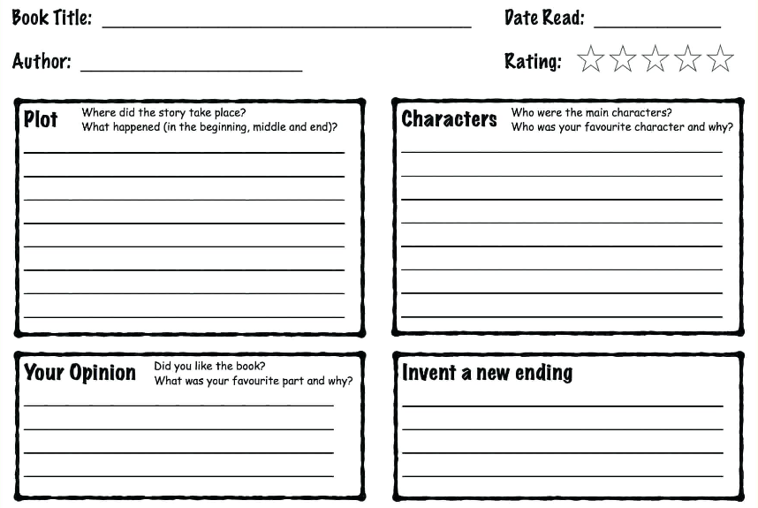

**Name: __________________ Class ________ KS2 Book Review**

**Book Title: __________________________________**

**Author: _____________________________________**

**Parent comment box. How do you feel your child has got on reading this book?**

Signed ……………………………………….. Dated …………………………………………

What will you read next?

**New Vocabulary and the meaning of the new word:**

_____________________________________________

______________________________________________

______________________________________________

______________________________________________

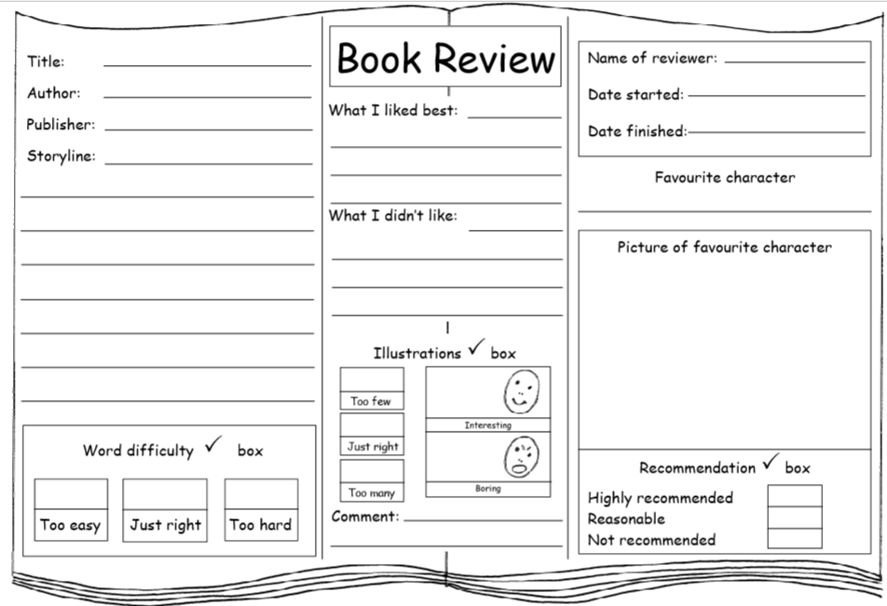

**KS1 Book Review**

What will you read next?

**Parent comment box. How do you feel your child has got on reading this book?**

Signed ……………………………………….. Dated …………………………………………