 |  |  | Holmer C of E Academy
 | Topic: Technology around us |  | Year: 2 | Strand: Digital photography
  What should I already know?
  - What a photograph is
  What will I find out by the end of the unit? |  | Vocabulary
   |  | Digital device | A physical unit of equipment that contains a computer
    To use a digital device to take a photograph
    To make choices when taking a photograph
    To take photos in both portrait and landscape
    To describe what makes a good photograph
    To decide how photographs can be improved
    To use tools to change an image
    To recognise that photos can be changed
   |  | Digital photo | Uses cameras to produce images focuses by a lens
   |  | landscape | Horizontal viewpoint of something
   |  | portrait | Vertical viewpoint of something
   |  | retaking | To take again
   |  | Light sources | Anything that makes light, either natural or artificial
   |  | unclear | Not easy to see
Computing Skills and Enquiry
- Use technology purposefully to create, organise, store, manipulate, and retrieve digital content
- Recognise common uses of information technology beyond school
- Use technology safely and respectfully, keeping personal information private; identify where to go for help and support when they have concerns about content or contact on the internet or other online technologies

 | Holmer C of E Academy - Computing
Topic: Technology around us | Year: 2 | Strand: Digital photography
- Explain how to capture a digital photo using a camera.

- Label these images with portrait and landscape. |  | 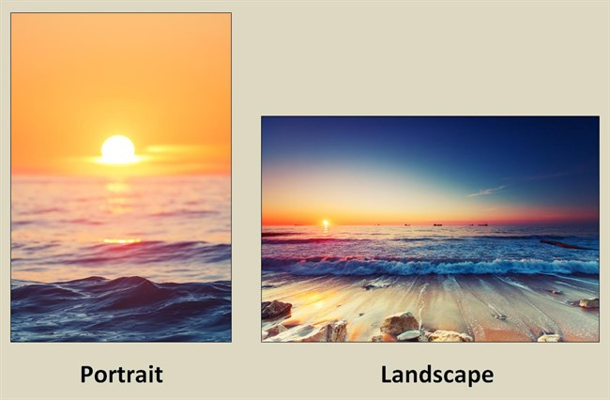
- Circle the best photograph. Explain how the other one can be improved. |  |   

