N
What should I already know?
Which stories are special and why? * Sacred places *Why do Christians perform nativity plays at Christmas? *What places are special and why? * Why does Christmas matter to Christians? *Easter salvation * Where do we belong *Why Easter matter to Christians Why is the word God so important to Christians? * What do Christians believe God is like * Christian churches *Who is Jewish and what do they believe? *How and why do we celebrate special and sacred times?

Diagram

Vocabulary
Creation | - The bringing into of existence of the universe, especially when regarded as an act of God.
Valuable | Extremely useful or important
Faith | Strong belief in God or in the doctrines of a religion, based on spiritual apprehension rather than proof.

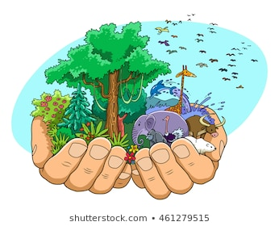

RE skills
Making sense of the text  Understanding the impact  Making connections | Understanding the impact | Making connections

- Recognise that some people believe God created the world and so we should look after it.
- Re-tell Bible stories about the idea of Creation.
- Begin to understand what the story tells Christians about God, Creation and the world.
- Give examples of how Christians say thank you to God for the world.
- I will be able to ask questions about living in an amazing world.

Related Reads

When God Made the World Hardcover – January 28, 2020 by Matthew Paul Turner (Author), Gillian Gamble (Illustrator)

The Creation Story for Children Hardcover – August 13, 2009
by Helen Haidle (Author, Illustrator), David Haidle (Author, Illustrator)

What will I know by the end of this unit?

 | Start of unit: | End of  unit:
Who do Christians and Jews believe created the world?
Tell me one thing Christians believe God created.
How do Christians show their thanks for the world in which they live?

